**Bahria University, Lahore Campus**

Department of Computer Sciences

Lab Journal 06

**(Fall 2023)**

|  |  |  |
| --- | --- | --- |
| Course: | **Digital Communication Network Lab** | Date: 26-10-2023 |
| Course Code: | CSL-320 | Max Marks: 20 |
| Faculty’s Name: | Dawood Akram | Lab Engineer: Muhammad Umar Nasir |

Name: _____________________________ Enroll No: _______________________

**Objective(s):**

In this lab, students will learn how to implement routing information protocols using packet tracer.

## Tool(s) used:

CISCO packet tracer

The **Routing Information Protocol** (**RIP**) is one of the oldest [distance-vector routing protocols](https://en.wikipedia.org/wiki/Distance-vector_routing_protocols) which employ the [hop count](https://en.wikipedia.org/wiki/Hopcount) as a [routing metric](https://en.wikipedia.org/wiki/Metrics_(networking)). RIP prevents [routing loops](https://en.wikipedia.org/wiki/Routing_loop_problem) by implementing a limit on the number of [hops](https://en.wikipedia.org/wiki/Hop_(telecommunications)) allowed in a path from source to destination. The maximum number of hops allowed for RIP is 15, which limits the size of networks that RIP can support. A hop count of 16 is considered an infinite distance and the route is considered unreachable.

**Application of RIP (routing information protocol) version 1 and version 2**

**Main Commands**   
  
You need to advertise only the classful network number, not a subnet.

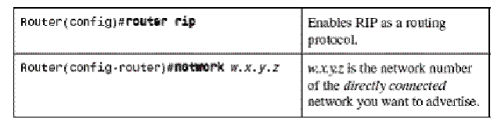

**Task 01 Apply RIP protocol on the following topology.**  
  
Now, we will follow the steps as mentioned in detail in the following Lab.   
**Step 1:** We will assign IP addresses to all the fast Ethernet and serial interfaces respectively.   
**Step 2:** We will change the state of the interfaces from down to UP.   
Then, after we are done with the basic step. We will apply RIP protocol commands on both routers.   
 **R1**  
**Step 3:** In order to apply protocol RIP, we will write the following set of commands.

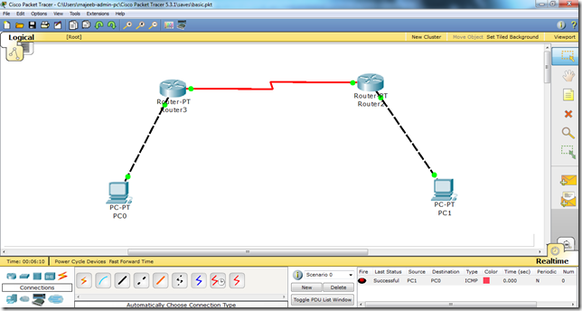

Router(config)# router rip

Router(config-router)# network 192.168.1.0

Router(config-router)# network 192.168.2.0

Router(config-router)#exit

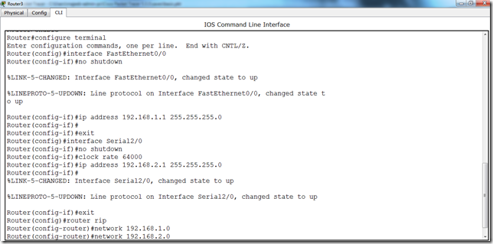

**R2:**  
**Step 4:** In order to apply protocol RIP, we will write the following set of commands on R2 as well. Router(config)# router rip

Router(config-router)# network 192.168.1.0

Router(config-router)# network 192.168.2.0

Router(config-router)#exit  
Write all the commands in the same fashion as in the above screen shots and voila, we are done with RIP protocol. Another important thing here is that we will add all the networks that we are using in our topology. Here in this particular example just use two networks x.x.1.0 and x.x.2.0 so thats why thses are added these two network addresses to the RIP protocol.  
  
**Task 02 Check traffic is enabled and you can easily send data from PC0 to PC1.**

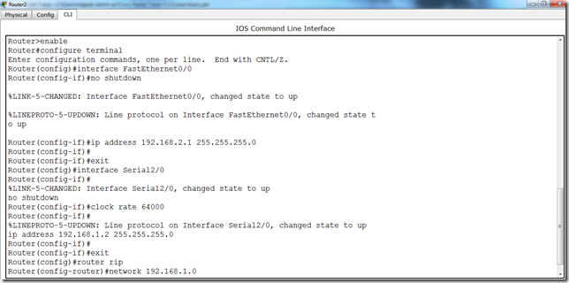

**Step 1: RIP V2**

There is no big difference between RIP version 1 and version 2 when we are applying them in packet tracer. In order to apply RIP version 2 on packet tracer. We will just have to add the following command. Follow the same example that we used in RIP version 1.



Router(config)# router rip

Router(config-router)# network 192.168.1.0

Router(config-router)# network 192.168.2.0

**Router(config-router)# version 2**

Router(config-router)#exit

You see there is just the addition of one statement i.e. “version 2”. The rest is the same. Apply the above set of commands on both routers i.e. Router 3 and Router 2 ,used in the topology above. Just make sure that the protocol is applied as an additional step and cannot replace the basic steps i.e. Assign IP addresses to the router’s interfaces and PCs and also change the state of the interfaces from down to UP like we did above and then we will go ahead and apply protocol.